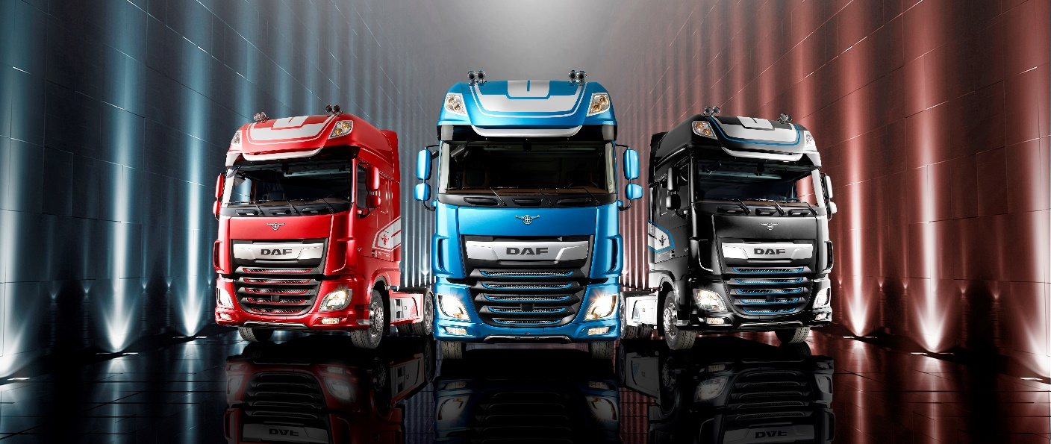

DAF Suppliers Questionnaire

Suppliers Questionnaire

DAF concentrates on the development, production, marketing & sales and services of medium and heavy trucks. Therefore DAF Trucks is focused on its core-activities and expects its suppliers to do the same. DAF builds on the specific knowledge that the supplier has from its speciality. Through this DAF depends more and more on its suppliers.

To give DAF a good overview of your conduct of business, we kindly ask you to answer this questionnaire. The questions are classified as follows:
- general;
- quality and environment;
- logistics;
- know-how;
- competitive position;
- price; and
- product family specific.

After receiving your information, we will verify the information you have sent.

All information given by you will of course be treated confidentially.

0. General:
0.1. Information about the supplier:
0.1.1 General:
- name :
- address : (street, town, country)
- telephone :
- E-mail address :
- Internet address : Http:\\
- VAT number :
- Bank details :
0.1.2 Contact person (name/position):
- Management :
- Quality :
- Logistics :
- Technical :
- Commercial :
- Environment :

0.2 History:
0.2.1 Give a brief outline of the history and growth of the company. Please submit a copy of your most recent annual report.
0.3 Policy:
0.3.1 Give a brief outline of the strategy/policy of your company in respect of the following components, for the coming year.
0. General:
1. Quality:
2. Logistics:
3. Know-how:
4. Competitiveness:
5. Product Family Specific:
6. Environment: and
7. Others.
0.3.2 What are the key investments planned for the coming years?

0.4 Organisation structure:
0.4.1 What is the legal structure of the organisation?
0.4.2 Submit an organisation chart showing:
- for each department, the key personnel with an indication of position and main responsibilities;
- any ties with other companies (part of a larger organisation); and/or
- any other branches, stating which products are made where.
0.4.3 How many company employees are employed totally? Of these employees, what is the ratio of direct to indirect? What is the ratio between permanent and temporary employees?
0.4.4 Have strikes occurred over the last five years (when, how long, why)?
    - What are the turnover and absenteeism percentages amongst staff (% over the last five years)?
0.4.6 How is your quality service structured (submit as an appendix an organisation chart of the quality department, together with a job description for the head of this department)?
0.4.7 Indicate on the chart how many personnel have a full day task in quality assurance (in each department).
0.4.8 Describe levels of automation and detail systems for ERP, MES, SPC

0.5 Range of products:
0.5.1 State the principal products, with a breakdown into sort and where applicable material, weight, main dimensions, etc., and indicate the annual production per product group.
0.5.2 Give a brief outline of the production process, describing the various stages. Provide a summary of the key production equipment (type, characteristics, capacity, etc.).
0.5.3 Give an overview of the key materials used/processed by your organisation.
0.5.4 Does your organisation carry out assembly activities and if so what activities and for whom?
0.5.5 Give an overview of product automation and describe your –embedded- software development tools and capabilities.

0.6 Customers:
0.6.1 For the following three items, state: the main customers, the product types and the percentage of turnover of suppliers, as compared with total turnover:
a. the non-automotive industry;
b. the car industry; and
c. the truck industry.
0.6.2 Has there been or do you expect a major shift between the groups outlined above. If yes, indicate how much this shift is/will be, and if possible provide an explanation for the shift.
0.6.3 Do you supply products to military authorities (if so, what and how many)?

0.7 Suppliers:
0.7.1 How are suppliers selected, and what levels do you demand, in respect of quality?
0.7.2 Who are your main suppliers, and what do they provide (what is the share in respect of turnover)?
0.7.3 Give a brief outline of the systematic, preventive measures taken, to ensure that purchased products/services apply with specifications.
0.7.4 Do you use sample and/or zero series inspection procedures?
0.7.5 Briefly outline the strategy in respect of your suppliers.
1. Quality and Environment:

1.1 Quality system:
1.1.1 According to what standard is your Quality assurance system certified (please submit a copy of the certificate)?
1.1.2 Has your quality management system been recently assessed by larger customers (>10% of turnover) or by third parties? If yes, by whom, when and with what result?
1.1.3 Do your customers have a vendor rating or assessment of your performance or process (who and what is the result)?
1.1.4 Do you measure customer satisfaction, and if so, what is the result?
1.1.5 With which Q-tools and techniques have you established experience, and when do you use these tools and techniques?
1.1.6 How have you guaranteed the continuous improvement of the organisation?
1.1.7 What quality objectives has your organisation set for the coming year?
1.1.8 If possible, list the target and achieved performance over the last three years for the following components:
- COQ (Costs of Quality);
- Rejection percentage; and
- PPM.
    - Has your organisation implemented the 6σ-program?

1.2 Corrective and preventive action (following IATF requirements):
1.2.1 How is corrective action guaranteed (describe for the following subjects):
- handling customer complaints (in the event of product non-conformity);
- investigation into causes of non-conformity in product, process, quality system;
- how these causes are translated into corrective action;
- measurement of actions implemented and achieving expected results.
    - How are preventive actions guaranteed?
    - Are you familiar with the 7 steps or 8D or A3 closure forms?
    - What is the average lead-time for carrying out corrective and preventive actions?
1.3 Compliance Goods (Environment)
    - Do your products/materials and services comply with all national and international regulations, requirements, directives and government provisions with respect of the environment?
    - Are there any legal procedures undertaken against your organisation under administrative, civil or criminal law with respect of environment the last 5 years? If so, please give a brief outline.

1.4 Compliance Vendor (Environment)
1.4.1 Are you obligated to have environmental permissions? If yes for which areas;
do you have the current permissions (till when are they valid); by which authority were they given and please submit a copy.

1.5 Environmental Management System (EMS)
    - Does your organisation hold an environmental certificate (BS 7750, ISO 14001, EMAS, other)? If yes, please submit a copy. If no, what is your planning concerning certification for environmental aspects?
    - Does your organisation publish an environmental annual report? If yes, please submit a copy.
    - What are the goals on the area of environment?
    - What are the targets for the coming year on the area of environment? What was the performance on these targets over the last year?
    - Does your organisation take measures for environmental protection, in respect of:
- emissions of substances harmful to the environment generated during production;
- limiting the number and quantity of harmful substances (waste and hazardous waste);
- energy saving;
- packaging;
- weight saving in the products produced; and/or
- policy measures in respect of your own suppliers.
    - In what languages are you able to offer Material Safety Data Sheets (MSDS)?

1.6 Software Process Management System (To fill in for companies who supply Software)
    - Is your company familiar with Software Process Management and assessments of Software Process Capability? (e.g. CMMI or SPiCE)
    - If so, which CMMI or ISO/IEC 15504 (SPiCE) rating has the supplier achieved. (Level 0 to 5)
    - If not, does your organisation follow documented processes and is there a system in place to ensure compliance of all SW process steps?
    - Does your organisation outsource SW activities? If so how do you review and validate the Tier 2 Supplier?
    - Does your organisation have and use a Configuration management archive/system?

2. Logistics

2.1 Logistic concept:
2.1.1 Do you produce on stock, on customer order or a mix of both?
2.1.2 Do you produce in a job-shop environment, in a flow production or a mix of both?
2.1.3 Do you make use of (customer) decoupling points? Where are they situated?
2.1.4 Which performance indicators do you use to control the goods flow? What was the performance on these indicators over the last year?

2.2 Systems:
2.2.1 What kind of information system do you have for materials requirement planning (ERP)?
2.2.2 What kind of planning method do you use (for example MRP, kanban, et cetera)?
2.2.3 How much time does it take to process a customer delivery schedule into your production planning?

2.3 Orders:
2.3.1 Do you have a system to measure the production progress?
2.3.2 What kind of system do you use to determine potential delivery problems? How do you communicate these problems to your customer?
2.3.3 What is the minimum order quantity you produce? What is the percentage of setup time within the total process?

2.4 Deliveries:
2.4.1 Do you support JIT based on net requirements?
2.4.2 Do you support supply in line sequence (synchronised with process of customer)?
2.4.3 Do you work with logistic service providers? (for stock keeping, packaging, subassemblies, service etc..)
2.4.4 Do you use returnable packaging? Which standards do you use?
2.4.5 Do you use bar coding for identification of goods?

2.5 Flexibility:
2.5.1 What is the average production lead-time of the production process?
2.5.2 What is the reaction time in case of quality problems?
2.5.3 What is your volume flexibility over time (+ and - in %)?
    - What is the amount of fixed days within your delivery schedule? What are these days based on?

2.6 Communication:
2.6.1 Which system do you use to communicate with suppliers and customers (EDIFACT, Odette, Internet, fax, post, et cetera)?
2.6.2 What kind of messages do you use (DELFOR ,DESADV, DELJIT, INVOIC, et cetera)?
2.6.3 How do you process customers’ data into your system?

2.7 Delivery reliability:
2.7.1 How is delivery reliability of incoming goods measured?
2.7.2 How is delivery reliability of customer orders measured?
2.7.3 What are the average scores achieved over the last year on delivery reliability?

2.8 Continuos improvement:
    - Which projects are undertaken to improve the logistic performance?
3. Know-how
3.1 Product development:
3.1.1 Briefly describe your:
a. R&D department (which activities are sourced out and which not);
b. your test facilities;
c. your laboratory; and
d. your facilities for prototype construction.
3.1.2 Have you established experience with simultaneous engineering? If yes, give examples and describe what part your organisation played.
3.1.3 Does your organisation have an operational project organisation? If yes, briefly describe the management tools employed.
    - In what fields do you have a leading role/specialisation in respect of technology of your products?
    - What kind of CAD-system does your organisation have? Is it possible to exchange data from these systems electronically?
    - Is your organisation capable to carry out FEM-calculations? Can these calculations also be carried out in combination of products of a third party?

3.2 System development:
3.2.1 Do you have experience with developing, manufacturing and delivering complete systems? If yes, give examples. How have you laid down the organisation of this process?

3.3 Production engineering:
3.3.1 On which components of your process do you apply SPC?
3.3.2 Please describe briefly the preventive maintenance programme for your production process?
3.3.3 Do you operate facilities for special processes (see below) and please indicate also which of these processes are contracted out, and to whom.
a. surface treatment?;
b. heat treatment?;
c. form processing?;
d. linking techniques?;
e. electronic manufacture?;
f. non-destructive testing?;
g. destructive testing?; and/or
h. if yes, describe the facilities.
4. Competitive position
4.1 Market position:
4.1.1 In what areas are you active?
a. local;
b. international; and/or
c. global.
4.1.2 How large was your market share over the last three years (%):
- National;
- International; and/or
- Global.
4.1.3 Over the last three years, your cost structure as compared with your competitors in your market segment has been (If necessary, provide explanatory notes):
a. higher (>2%);
b. equal (-2 to 2%); or
c. lower (<-2%).
4.1.4 Describe your general cost structure.
4.1.5 Please fill out the matrix given in appendix 1.

4.2 Profitability/solvency:
4.2.1 Over the last five years, what was the total equity and shareholders equity (possibly of umbrella organisation)?
4.2.2 Over the last five years, what were your turnover and profits (possibly of umbrella organisation)?

4.3 After sales:
4.3.1 Does your company operate its own after market organisation (if yes, what products, parts)?
    - Are DAF products or components sold via this after market organisation?

5. Price
5.1 Market or target conformity:
5.1.1 Over the last three years, your price as compared with your competitors in your market segment has been (If necessary, provide explanatory notes):
a. higher (>2%);
b. equal (-2 to 2%); or
c. lower (<-2%).
5.1.2 Who are your main competitors?

5.2 Open costing:
5.2.1 Are you conversant with the open costing method (explain why/why not)?
5.2.2 Are you willing to enter agreements with DAF concerning cost reduction seen over the longer term?

6. Product family specific
Together with the SMA team responsible for the relevant product family, this component must be harmonised. Points of departure for completing this component are listed below (4M’s):
6.1 Materials (input);
6.2 Method (production process);
6.3 Means (tooling);
6.4 Manpower (for example consider the necessary qualities and/or skills of personnel);
6.5 Output; and/or
  - Etc.
Appendix 1: Financial figures
Data/year: | Y | Y-1 | Y-2 | Y-3 | Y-4
Balance sheet (figures in € *1000)
Assets:
1. Total fixed assets (1a+1b)
1a. Tangible fixed assets
1b. Intangible fixed assets
2. Current assets total (2a+2b+2c)
2a. Inventories
2b. Receivables (debtor)
2c. Cash and cash equivalents
3. Total assets (1+2)
Liabilities:
4. Capital and reserves total (4a+4b)
4a. Accumulated retained earnings
4b Other capital and reserves
5. Long term liabilities (>1 year)
6. Short term liabilities total (6a+6b)
6a. Creditors due within one year
6b Other short term liabilities
7.Total liabilities (4+5+6)
Profit and loss account:
10. Net sales and revenues
11. Costs of sales and revenues
12. Gross margin (10 less 11)
13. Operating costs
14. Operating result (EBITDA) 12 less 13
15. Depreciations & amortisations
16. Net interest income/expense
17. Result before tax (14 less 15 and 16)
18. Extraordinary result
19. Tax
20. Net result (17 less 18 and 19)
21. Dividend
22. Share of third parties
23. Profit retention (20 less 21 and 22)
Ratios:
30. Profit-retention (in %)
31. Net profit in % of net sales and revenues
32. Current ratio (2/6)
33. Quick ratio ((2b+2c)/6)
34. Equity ratio (4/7)
Other:
35. Number of employees

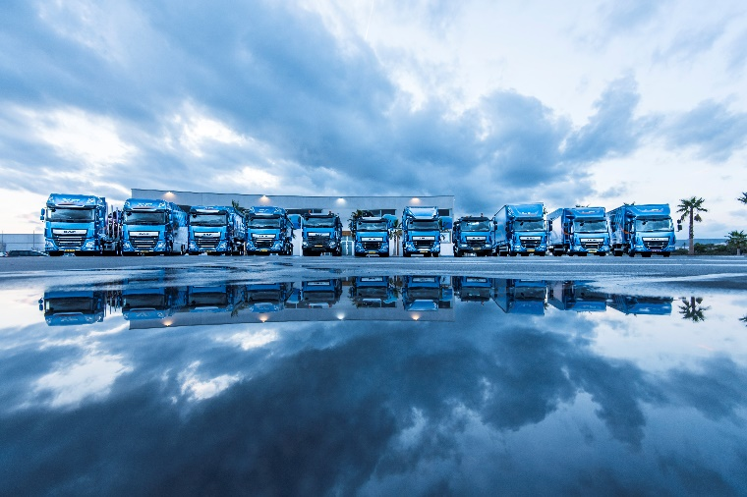

2018 Published by: Supplier Quality Assurance, DAF Trucks N.V.

No rights can be derived from this publication.
DAF Trucks N.V. reserves the right to change
product specifications without prior notice.
Products and services comply with the European
Directives effective at the time of sale but may
vary depending on the country in which you are located.
For the most recent information,
contact your authorized DAF dealer.

DAF Trucks N.V.

Hugo van der Goeslaan 1

P.O. Box 90065
5600 PT Eindhoven

The Netherlands

Tel: +31 (0) 40 21 49 111

website@DAFtrucks.com

www.daf.com

driven by quality

