XF H₂ Innovation Truck receives ‘2022 Truck Innovation Award’
DAF XF, XG and XG⁺ Awarded International Truck of the Year
DAF’s new generation of trucks for long distance haulage has been crowned ‘International Truck of the Year 2022’. “The XF, XG and XG⁺ set a new industry benchmark in efficiency, safety and driver comfort”, the jury stated after an extensive series of tests. The prestigious award was handed over at the Solutrans truck & transport exhibition in Lyon, France. DAF was also honoured the ‘2022 Truck Innovation Award’ for its XF Innovation Truck with a hydrogen combustion engine.
Based on the International Truck of the Year (IToY) rules, the annual award is presented to the truck which was introduced in the past year and which has made the most significant contribution to road transport efficiency. This judgment relies on a comprehensive range of criteria, including technological innovation, comfort, safety, driveability, fuel economy, environmental ‘footprint' and Total Cost of Ownership (TCO).
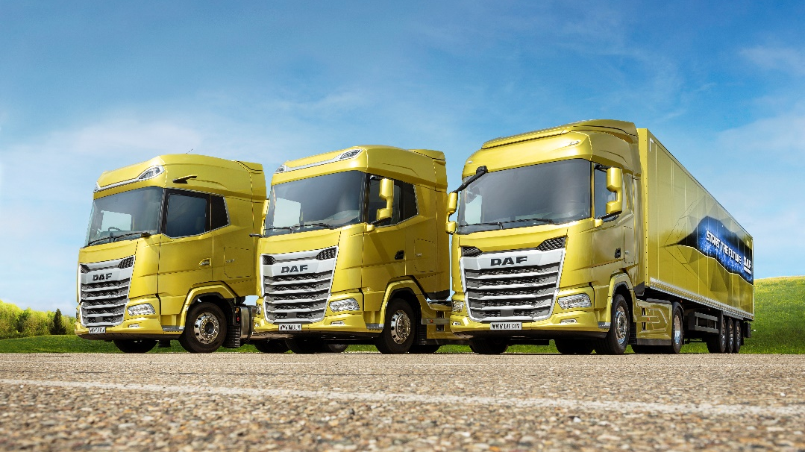
The New DAF XF, XG and XG+ have been awarded ‘International Truck of the Year 2022’
because of their class-leading efficiency, safety and driver comfort.
Industry-first
“DAF is the first truck manufacturer to introduce a completely new generation of trucks that has been developed with the new European regulations for truck masses and dimensions in mind”, said Gianenrico Griffini, chairman of the ‘International Truck of the Year’ jury. “The result is a series of highly attractive and very aerodynamic trucks which features class-leading efficiency, safety and driver comfort. The new XF, XG and XG⁺ offer excellent direct visibility provided by a large, curved windscreen, side windows with low beltlines and the kerb-view window. These features – along with the digital vision system that replaces the traditional side view mirrors and the new corner view camera – offer all-around view, protecting vulnerable road users”.
A true team effort
The prestigious award ‘International Truck of the Year 2022’ was presented to Harry Wolters, president of DAF Trucks, who dedicated the recognition to all of the over 12,000 DAF employees world-wide. “This unique achievement is a true team effort! The New Generation XF, XG and XG⁺ represents the largest innovation project in the over 90-year history of our company. It is the result of thoroughly listening to our customers and their drivers, having a clear vision about the future of durable and sustainable transport solutions and always going the extra mile to deliver the best possible transport solutions. Indeed, we are the first truck manufacturer that fully utilises the new European regulations regarding truck masses and dimensions to deliver unique benefits to our customers. It is good to be the first – it is even better to be unique.”
Summing up the jury vote, IToY jury chairman Gianenrico Griffini commented: “With the introduction of its new generation trucks, DAF has delivered a high-tech, heavy-duty vehicle range that sets a new benchmark in the industry. In addition, it is future-oriented, as it also represents a complete and very energy efficient platform for new generations of alternative energy carriers and drivelines.”
Truck Innovation Award 2022
A great example is the new XF with hydrogen internal combustion engine technology which DAF has under development and which impressed the International Truck of the Year jury during a demonstration in October. As a result, the DAF XF H₂ Innovation Truck was honoured with the ‘Truck Innovation Award 2022’.
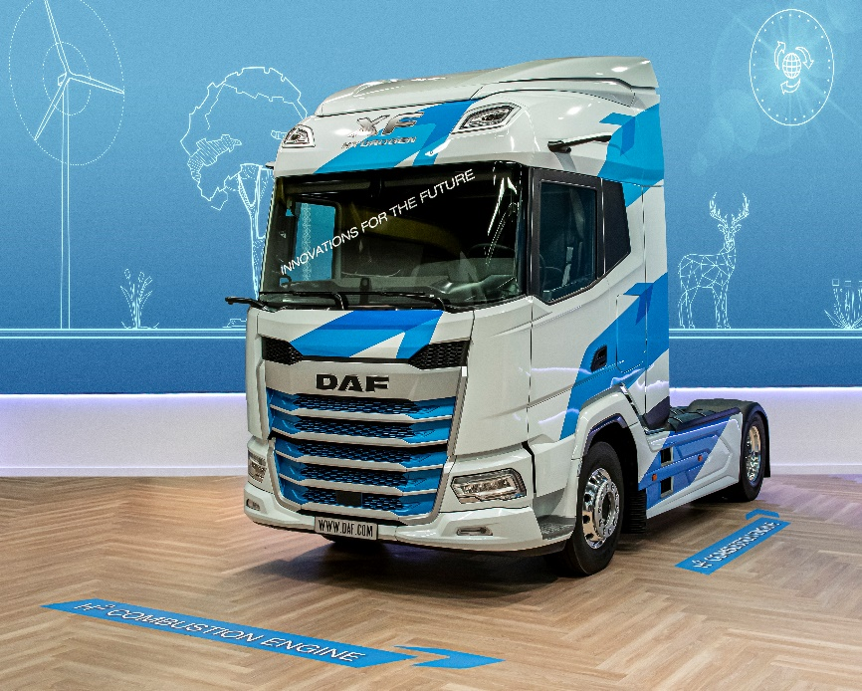
DAF’s New XF Hydrogen Innovation Truck won the ‘2022 Truck Innovation Award’.
The ITOY jury honored DAF’s innovative approach to alternative drivelines.
“This specific award underlines our philosophy that we need to explore the full suite of technologies on the road of decarbonisation of transport and mobility in the next decade”, commented Ron Borsboom, DAF executive director product development. “Hydrogen technology may become a very interesting option for the future, next to battery electric solutions which we already offer today and hybrid trucks which we have under development. Being honoured with the ‘Truck Innovation Award 2022’ also demonstrates that there is still a promising future for the internal combustion engine (ICE) for which new generations of carbon neutral fuels are on the horizon. It is important to understand that bringing an end to the use of fossil fuels should by no means automatically result in a ban on internal combustion engines, especially in the heavy duty long haul transport segment.”
Ron Borsboom added: “H₂-ICE means that in many areas use can be made of an existing distribution network of fuel stations. And let’s put more value in the fact that we in Europe have extensive knowledge and a manufacturing footprint in this technology.”
The International Truck of the Year jury consists of 24 commercial vehicle editors and senior journalists, representing the most important international truck and transport media titles.

Photo caption:
The DAF XF, XG and XG⁺ has been crowned International Truck of the Year. DAF Trucks President Harry Wolters received the Award from Gianenrico Griffini, chairman of the International Truck of the Year jury.

DAF Trucks N.V. — a subsidiary of PACCAR Inc, a global technology company that designs and manufacturers light, medium and heavy-duty trucks. DAF provides a full range of tractor units and vocational trucks, offering the right vehicle for every transport application. DAF is also a leading provider of services, including MultiSupport repair and maintenance contracts, financial services from PACCAR Financial and a first-class parts delivery service from PACCAR Parts.

Eindhoven, November 17, 2021

Note to editors only

For more information:
DAF Trucks N.V.
Corporate Communication Department
Rutger Kerstiens, +31 40 214 2874
www.daf.com

If you no longer wish to receive press releases from DAF Trucks N.V., please report this to Saskia van Zijtveld at saskia.van.zijtveld@daftrucks.com

Wilt u geen persberichten van DAF Trucks N.V. meer ontvangen, meldt u dit dan aan Saskia van Zijtveld via saskia.van.zijtveld@daftrucks.com.

